Z

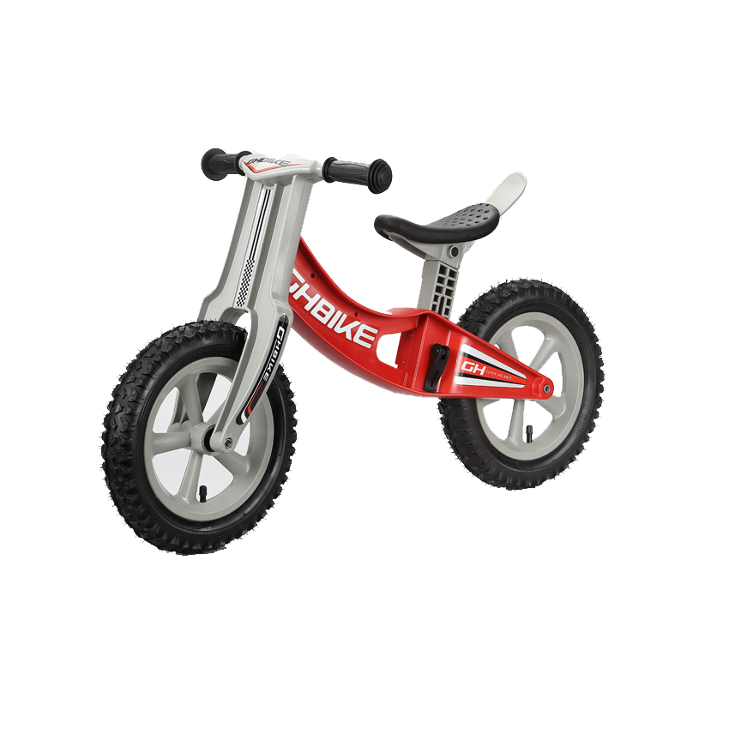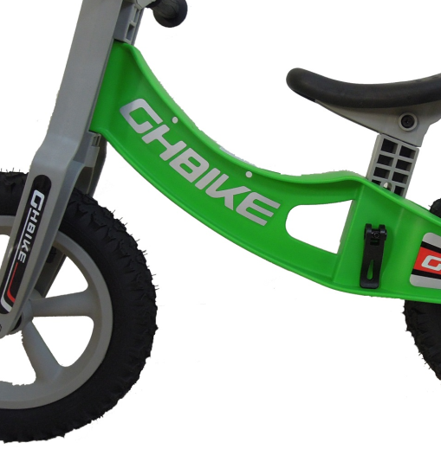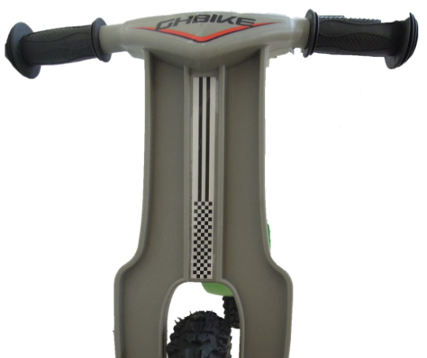

**Sticker position**

GH-525



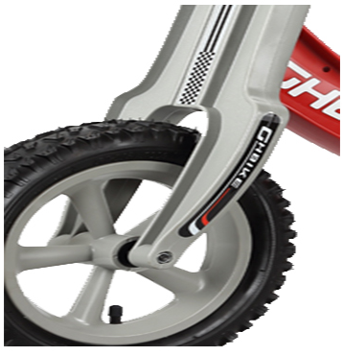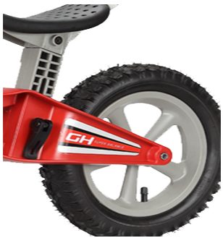

**Warning:**

**TO AVOID SERIOUS INJURY: Continuous adult supervision required. Make sure the**

**children hold on handles with both hands when cycling. Always wear a helmet, elbow**

**pads, knee pads and appropriate shoes. Please ride at safe area. Never use on public**

**roads, hills, near motor vehicles, swimming pools or other dangerous places. Allow only**

**one rider. Please carefully read and follow the owner’s manual. Periodically check the bike and**

**tires when cycling. Do not use it if there are any broken, deformed or missing parts of**

**the bike. Do not place the product in outdoors. Do not expose the product to high**

**humidity or excessive heat or direct sunlight environments and keep it away from ﬁre.**

**Geng Hung Co.,Ltd.**

<TEL:886-4-7511586>

FAX:886-4-7613280

E-mail:gh.bike@msa.hinet.net

[**www.ghbike.com.tw**](http://www.ghbike.com.tw)

MADE IN TAIWAN

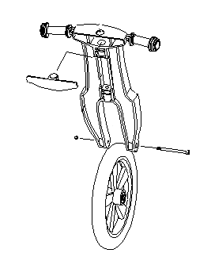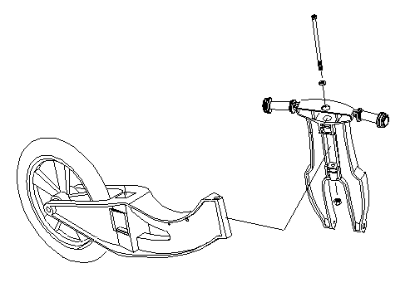

1

2

M12x150mm

The cover(4) for the front fork is used to close the opening at the top.

The bolt M8x100mm(3) and the nut M8(6), are used for securing the front wheel.

First, hold front fork(1) and the frame(10) together.

Insert the bolt M12x150mm(3) into the front fork aperture form top.

M12x150mm



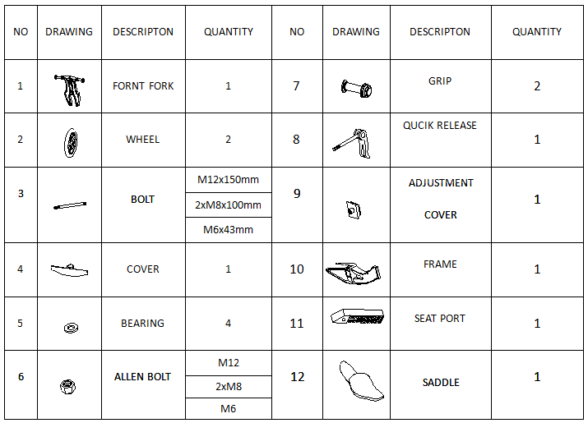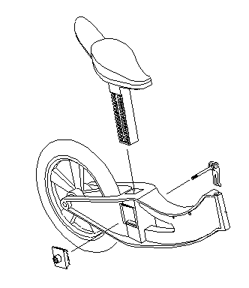

4

3

M8x100mm



Install Finish GHBIKE

The seat port(11) into the frame(10) square aperture.

The quick release(8) through seat port(11) and put adjustment cover(9) into frame(10)

M8

M8x100mm

M12